**Student Dashboard Wireframes-** Browser, Mobile and Tablet

Table of Contents

Browser 3

Login page 3

Student homepage 4

Uploads 5

Supervisor meetings 6

Diary/ blog 7

Tablet 8

Login 8

Student homepage 8

Uploads page 9

Supervisor meetings 9

Diary/Blog 10

Mobile 11

Login 11

Student Homepage 11

Uploads page 12

Supervisor meetings 12

Diary/blog 13

# Browser

## Login page

**\*NOTE: RED UNDERLINED TEXT IN WIREFRAME SIGNIFIES A LINK\***

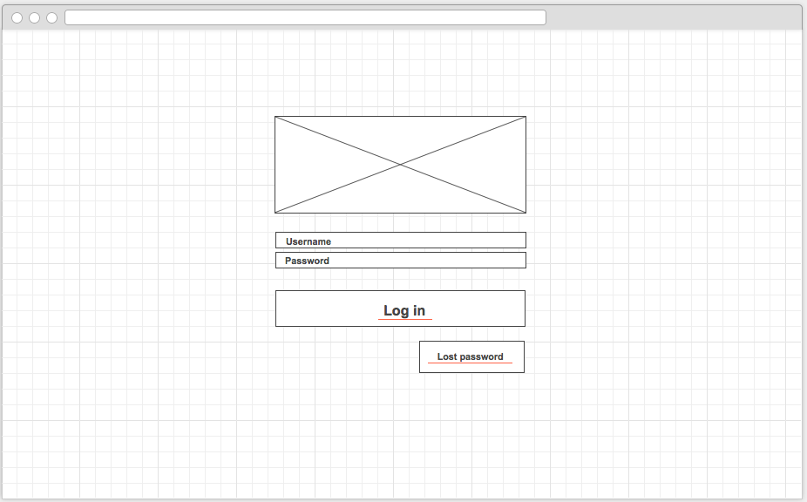

1. Our team logo goes here

## Macintosh HD:Users:kinzan:Desktop:dig med tech:year3:term2:COMP1640EntWebSoftDev:cw1:group:desigher:sitemap:images:new:StudentDash2.pngStudent homepage

2. Clicking on the names of both Supervisor and second marker will show each of their profiles (through CIS system).

3. Students can send messages to their supervisor/second marker via posting a comment, similar to posting a comment on Facebook.

Uploads page   
  
  
  
  
  
  
  
  
  
  
  
  
  
  
  
  
  
  
  
  
  
4. Student clicks on which document to upload e.g.” proposal/pitch/reports”, and a modal light box window pops up (see number 5)

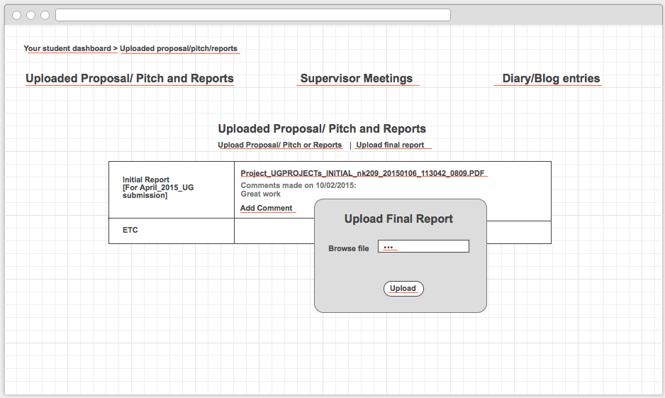

5. Student then chooses a file and clicks upload. File then displays in a table i.e. see first row of table. Student can then add a comment on that file through “add comment”.

## Supervisor meetings

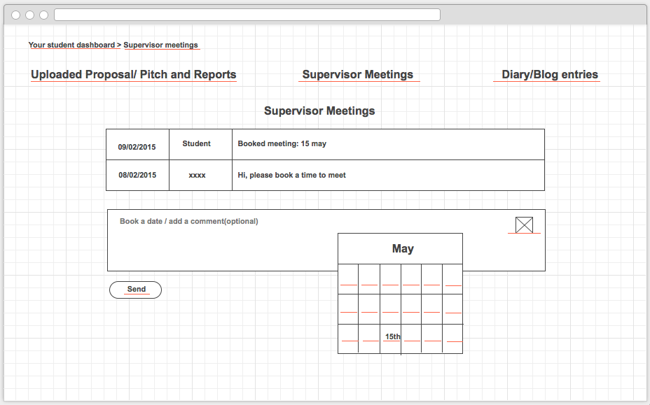

6. Icon of a calendar appears here. Student clicks on it and a calendar pops up allowing student to choose a data and add a comment with it if they wish.

7. Calendar displays, allowing student to book a meeting.

8. The booked date appears in the table

## :dig med tech:year3:term2:COMP1640EntWebSoftDev:cw1:group:desigher:sitemap:images:new:diary/blognew.pngDiary/ blog

9. Student adds blog entry

10. Blog entry appears here

# Tablet

## Login

# :dig med tech:year3:term2:COMP1640EntWebSoftDev:cw1:group:desigher:sitemap:images:new:ipad:login.png

## 

## :dig med tech:year3:term2:COMP1640EntWebSoftDev:cw1:group:desigher:sitemap:images:new:ipad:diary/blogTablet.png Student homepage :dig med tech:year3:term2:COMP1640EntWebSoftDev:cw1:group:desigher:sitemap:images:new:ipad:uploads.png:dig med tech:year3:term2:COMP1640EntWebSoftDev:cw1:group:desigher:sitemap:images:new:ipad:SupMeetings.pngUploads page

## Supervisor meetings:dig med tech:year3:term2:COMP1640EntWebSoftDev:cw1:group:desigher:sitemap:images:new:ipad:diary/blogTablet.pngDiary/Blog

# Mobile

## Login

## :dig med tech:year3:term2:COMP1640EntWebSoftDev:cw1:group:desigher:sitemap:images:new:phone:stuLogin.png

## :dig med tech:year3:term2:COMP1640EntWebSoftDev:cw1:group:desigher:sitemap:images:new:phone:stuDashMob.pngStudent HomepageUploads page

## :dig med tech:year3:term2:COMP1640EntWebSoftDev:cw1:group:desigher:sitemap:images:new:phone:uploads.png

## :dig med tech:year3:term2:COMP1640EntWebSoftDev:cw1:group:desigher:sitemap:images:new:phone:supMeetings.pngSupervisor meetings:dig med tech:year3:term2:COMP1640EntWebSoftDev:cw1:group:desigher:sitemap:images:new:phone:diary/blogMOB.pngDiary/blog